

**Department of**

**Physician Assistant Studies**

Preceptor Manual

2023

**To Our Preceptors**

The practical application of medical principles that our students learn during their didactic education is an invaluable, necessary experience. The Department of Physician Assistant Studies faculty at East Carolina University extends our inexpressible gratitude to our preceptors for providing students the opportunity for supervised clinical experience and for doing it with such understanding, enthusiasm, compassion, and dedication. Thank you for your service to the ECU PA students!

Kelley Hulihan MS, PA-C Shawn Wagner MBA, MMS, PA-C

Co-Director of Clinical Education Co-Director of Clinical Education

Carey McDonald, MBA

Administrative Clinical Coordinator

**Preview Points for 2023**

**We recognize that many of you have served as clinical preceptors for the PA program at ECU for many years. We wanted to highlight important points early in this document.**

**Interim Progress Reports (i.e., the Mid-Point Check-in):** We will continue to utilize Mid-Point Check-Ins as a communication tool and platform for feedback between students, preceptors, and the program. In our experience, the sooner students receive feedback, the sooner they can improve. Good feedback is 1. Clear 2. Timely, and 3. A good discussion follows them. See page 7 for additional advice on feedback.

Please feel free to contact the Co-Directors of Clinical Education with concerns or issues that arise during the practicum.

**Final Preceptor Evaluation:** Last year, we redesigned this evaluation to align with our accrediting body requirements. We are using a competency-based scale: Below Avg Clinical Year Student, Average Clinical Year Student, Above Average Clinical Year Student, or at the level of a New PA Grad. Final Preceptor Evaluations are rotation specific.

* Unsure what these expectations mean? For reference, a ***clinical year PA student should be working roughly at the level of an M4 (and is expected to progress during the year)***. A ***new grad PA should be working roughly at the level of a first rotation intern (R1)*** in terms of the ability to evaluate patients, report information to the team, and consider decisions for patient management.
* A student practicing ***below the level of a clinical year PA student would be someone working at the level of an M2***—who struggles with basic skills related to history and physicals, critical thinking, and more.
* Students are **expected to progress** from performing **at the level of a clinical year PA student to the level of a new graduate PA over the course of their 12 months of rotations. Please evaluate them honestly and fairly. Honest feedback about their performance is necessary for their development throughout the clinical year and encourages lifelong learning and improvement.**
  + If you need further advice on how to complete this form, please do not hesitate to email Kelley Hulihan MS, PA-C or Shawn Wagner MBA, MMS, PA-C, Co-Directors of Clinical Education: [hulihank19@ecu.edu](mailto:hulihank19@ecu.edu), [wagnersh17@ecu.edu](mailto:wagnersh17@ecu.edu) or Carey McDonald, Administrative Clinical Coordinator [mcdonaldc@ecu.edu](mailto:mcdonaldc@ecu.edu).
* COVID: students must sign a Covid liability waiver before each rotation.
  + [COVID Waiver Form](https://www.google.com/url?client=internal-element-cse&cx=009803953143912655678:qepjjts9jxg&q=https://rede.ecu.edu/wp-content/pv-uploads/sites/383/2018/04/Internship-Assumption-of-Risk-and-Liability-Waiver.docx-excluding-specific-risk-level.docx&sa=U&ved=2ahUKEwj99P_70c_1AhVaJEQIHWZGCj4QFnoECAAQAQ&usg=AOvVaw14BNHfi6yqZ9yN5UpAQpho)
* They have undergone training on methods to keep themselves and others safe.
* Students are always expected to wear a clean mask, covering their nose and mouth while on rotations. This includes charting areas, lunchroom, etc.
  + Students have been instructed to
    - Not to report to rotation sites if they are experiencing any Covid symptoms or have had a known exposure. [CDC guidelines](https://www.cdc.gov/coronavirus/2019-ncov/vaccines/index.html?s_cid=11759:cdc%20travel%20guidelines:sem.ga:p:RG:GM:gen:PTN:FY22)
    - Contact the preceptor and the clinical team if they are experiencing symptoms or have known exposure.
    - Contact ECU student health services for guidance regarding testing and quarantine.
    - Quarantine as directed and communicate this information to the preceptor and the clinical team.
  + Regular screening for symptoms and ongoing self-monitoring throughout the day can help to identify signs of illness and help reduce exposure quickly. All University students must carefully monitor their health every day. The following COVID-19 Monitoring Checklist must be considered each day before reporting in person to any classes or activities at the University:
    - • Fever or chills  
      • Cough  
      • Shortness of breath or difficulty breathing  
      • Fatigue  
      • Muscle or body aches  
      • Headache  
      • New loss of taste or smell  
      • Sore throat  
      • Congestion or runny nose  
      • Nausea or vomiting  
      • Diarrhea
  + If possible, students who miss rotation time are expected to make up clinic time and receive relevant supplemental work to continue learning while on quarantine.
  + The clinical team will follow health officials' recommendations regarding quarantine, isolation, and/or return to clinic instructions. Students need to submit a return to work from a healthcare provider to the clinical team.

Students have a Clinical Skills Checklist to be 100% completed during their clinical year. These skills are required to demonstrate competency before completing the program. These skills need to be signed off by preceptors to demonstrate competency in the skill.

A word about time off during clinical rotations: ECU Clinical Year PA Students do not have scheduled breaks. They are allotted 5 personal days to use during clinical rotations. They may use a maximum of 2 personal days in one 4-week rotation. The preceptor and the program must approve personal days.

**CME**

Individual PA preceptors may be awarded 2 AAPA Category 1 CME credits per student per 40 hours of precepting time. Note that there is no maximum.

<https://www.aapa.org/cme-central/aapa-cme-accreditation/category-1-cme-for-preceptors/>

For NP preceptors, we will provide a letter for you to submit to your board. Please contact Shawn Wagner at [wagnersh17@ecu.edu](mailto:wagnersh17@ecu.edu) for more information.

**Contents**

Physician to Physician Assistant Team Concept 5

Preceptor Role Information 5

Preceptor Expectations: 6

We request that you do your best to provide: 6

Why should I want to be a preceptor? 7

How do I prepare for a student coming to my office? 7

What can students learn from me? 7

How do I evaluate students? 8

How do I give feedback to a student? 8

What are the characteristics of good preceptors? 8

Policy for Monitoring Physician Assistant Students in the Clinic or Hospital Setting 9

The clinic/hospital is expected to 9

The sponsoring preceptor (MD, DO, PA-C, NP, CNM) is expected to 9

The student is expected to 9

The training program (ECU PA) is expected to 10

Appendix A 11

Master of Science in Physician Assistant Studies Curriculum 11

Didactic Curriculum 11

Clinical Curriculum 12

Appendix B: (Mid-Point Check-in Form) 13

Appendix C: (Example: Family Medicine Final Preceptor Evaluation) 14

Appendix D: (Example: SCPE Evaluation – the student’s evaluation of preceptor and clinical site)………… 17

# Physician-to-Physician Assistant Team Concept

The physician assistant (PA) is a highly skilled ***dependent*** healthcare professional trained to practice medical skills under physician supervision. Physicians conceived the physician assistant's scope of practice and philosophy. The physician assistant training curriculum is designed in a medical model, like physicians. The physician assistant is disciplined academically, clinically, and philosophically as a ***dependent*** provider, augmenting the physician's quality of health care.

The history of the physician assistant as a dependent provider cultivates a unique relationship with the physician. This collaborative affiliation is termed the **Physician-Physician Assistant Team Concept**. The Physician-Physician Assistant Team Concept maintains the physician as the principal manager and authority of health care delivery. The Physician-Physician Assistant Team Concept is a well-recognized healthcare team used extensively throughout North Carolina and the United States for over fifty years.

The North Carolina Academy of Physician Assistants and the East Carolina University Physician Assistant Program are committed to the Physician-Physician Assistant Team Concept. It is promoted as a fundamental maxim of physician assistant professional practice. The Physician-Physician Assistant Team Concept is encouraged as one of the best solutions for providing accessible quality health care.

The distinctive relationship between the physician and physician assistant demands the intimate collaboration of both professions in addressing healthcare issues in North Carolina.

# Preceptor Role Information

* **General Information**: The Physician Assistant Studies Program at East Carolina University strives to provide an exemplary education to students for careers in primary health care and care for the underserved and those in rural areas. As future healthcare team members, we teach our students to assist physicians in providing patients with preventive and primary healthcare services. PA students entering their clinical year have received 15 months of intensive education in the basic, behavioral, and clinical sciences. This includes intensive normal anatomy and physiology instruction, pathophysiology, clinical decision-making, and clinical medicine. PA students are trained in taking medical histories and performing physical examinations before entry into the clinical year. In addition, they have taken courses on clinical decision-making and should be able to identify historical and physical findings common to frequently encountered forms of the disease.
* **Purpose of clinical practicum experiences**: Clinical practicum experiences enable PA students to sharpen their primary care skills and learn the intricacies of medical practice. For preceptors unfamiliar with physician assistant education, comparing the clinical practice with clerkships performed by third- and fourth-year medical students is useful. A preceptor should typically allow the student to formulate an assessment of the patient and, after establishing a working diagnosis, present the patient to the preceptor and work with the preceptor to plan therapy. The primary goal is for the student to gain practical experience, develop skills as a healthcare practitioner, and learn the role of other healthcare team members. The practicum also emphasizes the dependent role of the Physician Assistant and the Physician-Physician Assistant Team Concept. To facilitate this, students are available for practicum activities a **minimum** of 32 hours a week, 40 or more preferred. Days off and holidays will follow the schedule of the supervising preceptor. The maximum work hours per week should not exceed 80 hours, including 1 day off in 7 days, and duty periods should not exceed 24 hours at a time.

**Preceptor expectations:**

* Supervise student’s clinical activities
* Overseas student’s progress on clinical skills and experiences in Competency Log (Typhon)
* Provide a fair and honest evaluation of the student’s abilities during and on completion of the practicum, including completion of a mid-rotation check-in & end of rotation preceptor evaluation.
* Assure that students will not be used to substitute for regular clinical or administrative staff.
* Complete a simple student evaluation form at the end of the practicum that can be done electronically or may be faxed or even mailed by the preceptor to the PA program.
* Allow the student to attend any required meetings at the PA Program Campus. All exams are administered by the Academic PA Program faculty and are not required of the preceptors.
* Make sure that the student follows all HIPAA and Blood Borne Pathogen/TB policies, regulations, or laws and reports any infectious disease exposures to you and the PA Program immediately.
* Follow ethical medical practice guidelines, including avoiding providing treatment/care to any student for medical conditions or completing forms, accepting or providing gifts, and/or developing non-professional relationships with students.
* **Give students clear, concise, and timely feedback on academic performance & professionalism.**
* See the addendum for a copy of the student site and preceptor evaluation.

**We request that you do your best to provide:**

* An environment conducive to learning (free of bullying, harassment, or other disruptive behaviors)
* Regular feedback on patient care, interactions with staff, professionalism, and interpersonal skills
* Guidance as a mentor and role model
* Direction for the student to become a self-motivated lifetime learner

**Student Supervision**: Although PA students can be expected to evaluate all types of patients, they are not yet licensed practitioners. During the clinical practicum, a preceptor with legal authority to provide medical care for the patient must supervise PA students. In some cases, the student may present cases to a graduate PA or nurse practitioner working for the designated physician-preceptor. However, the responsibility for supervising the student and the care rendered by that student must rest with the physician-supervisor. With this said, students should be allowed to do more than shadowing during their supervised clinical practicum experiences (SCPEs). Hands-on application is key to a successful SCPE.

**Preceptor Support**: The PA program employs full-time, graduate physician assistants who serve as Clinical Coordinators. These faculty members serve as points of contact and support for students and preceptors. Before assigning a student to a site, the Clinical Coordinators provide personal orientation for preceptors. Preceptors are provided with the preceptor manual, the practicum syllabus, and guidance on completing evaluation forms. If requested, the Clinical Coordinators will also orient the office and medical support staff. The Clinical Coordinators, the Program Director, or a PA Faculty member will make scheduled site visits to each active clinical site at least every 2 years. A preceptor should call one of the clinical coordinators with any concerns or questions. The clinical coordinators are always available as unforeseen circumstances may arise at a clerkship site. **Preceptors are encouraged to contact a Clinical Coordinator whenever a concern arises regarding a student’s performance or professional behavior.**

**Co-Director of Clinical Education**

Kelley Hulihan, MS, PA-C

Office: 252-744-1108, Cell: 518-231-5506 E-mail: [hulihank19@ecu.edu](mailto:hulihank19@ecu.edu)

**Co-Director of Clinical Education**

Shawn Wagner, MBA, MMS, PA-C

Office: 252-744-6273, Cell: 252-702-8304, E-mail: [wagnersh17@ecu.edu](mailto:wagnersh17@ecu.edu)

**Administrative Clinical Coordinator**

Carey McDonald, MBA

Office: 252-744-1750, Cell: 252-327-2653, E-mail: [mcdonaldc@ecu.edu](mailto:mcdonaldc@ecu.edu)

**Criteria for Selection:** Practicum site selection is based on the type of practice provided (both specialty and practice setting), the demographics of the population served, the sufficiency of patients to provide adequate experiences for students, the experience and commitment of preceptors (board certification is preferred), the preceptor’s knowledge of the role of the PA, the adequacy of physical facilities for teaching and study, as well as the geographic location of the site.

***How much time does it take to be a preceptor?***

The amount of time you spend as a preceptor will depend on many factors related to you, your practice, and your student. Most studies have estimated that the cost in time of having a student in the office is 30-45 minutes per day based on the student being assigned to the office for a full day. The time will vary depending on the type of activities you and your student are involved in. One example of how to work a student into your practice is shown below (Lesky 1995, Ferenchick 1996)

|  |  |  |
| --- | --- | --- |
| Schedule “Wave” Model for ambulatory care teaching sites | | |
| 8:00-8:20 a.m. |  | Student sees 1 patient while preceptor sees 2. |
| 8:20-8:40 a.m. |  | Patient 1 is seen by student and preceptor together. |
| 8:40-9:00 a.m. |  | Student charts on patent 1, while preceptor sees patient 3. |
| 9:00-9:20 a.m. |  | Student sees patient 4 while preceptor sees patient 5. |
| 9:20-9:40 a.m. |  | Patient 4 is seen by student and preceptor together, etc. |

***Why should I want to be a preceptor?***

Teaching students is a way to keep current by responding to the inquiries of bright, young students. Preceptors find teaching is a good way to stay connected with their alma mater or the local medical school. You also will have an opportunity to affect our nation’s workforce. With high-quality physician assistant clerkships, more students may be inspired to pursue a career in primary care or your discipline. Upon request, a preceptor may be granted an appointment as affiliated or adjunct faculty in the East Carolina University College of Allied Health Sciences. As a preceptor, you may also be able to recruit colleagues for your medical practice, especially for those of you who work in rural and underserved areas. Other incentives include MD/DO – Cat 2 CME, PA-C – Cat 1 AAPA CME <https://www.aapa.org/cme-central/aapa-cme-accreditation/category-1-cme-for-preceptors/>, NP – CEU letter.

***How do I prepare for a student coming to my office?***

Once you have received and reviewed the instructive materials on preceptorship from the school, you should share them with your colleagues and staff so that you will have involved them. You will also want to prepare some basic information for your student about your practice and the community. Students are expected to contact your office before their practicum to confirm all directions for their clerkship at least 2 weeks before arrival.

***What can students learn from me?***

Most students will eventually practice as Physician Assistants in the community. Students can learn from your experience and expertise in a specific field of medicine. Working with patients and obtaining feedback on their skills will build their confidence. They will also see the application of their medical and basic science knowledge, procedural skills, and relationship skills with physicians, patients, and community resources. Students will also be able to see the importance of professionalism modeled by you and your staff.

One example of how to pass along information effectively and efficiently is called “The One Minutes Preceptor.” Video link: [Take 5: One Minute Preceptor - YouTube](https://www.youtube.com/watch?v=eRBdfXRj5N0&list=PLPSMskl_Gz29nRNdGSG1ywLR_3CBTG4vT&index=2&t=9s)

***How do I evaluate students?***

You should evaluate the student based on a series of observations during the practicum. Evaluation should emphasize changes in behavior (improvement) and progress toward practicum objectives and goals. Throughout the practicum, preceptors should provide constructive feedback to students on their performance. A rotation has 2 major evaluation points: 1) Mid-Point Check-in and 2) Final Preceptor Evaluation.

We recommend that you make an initial observation at the beginning of the practicum to determine the skills of the student at baseline. The practicum mid-point is often a good time to meet with the student to discuss performance and develop a plan for improvement during the remaining weeks of the practicum. At the conclusion of the practicum, preceptors should complete a final evaluation to determine the student’s overall grade. Other ways to evaluate students include reviewing and signing off student documentation and skills log at the end of the practicum.

***How do I give feedback to a student?***

Students are anxious to know how they are doing. Asking them to tell you how they think they have handled specific patient issues or interactions will help you determine how accurately the students can judge their competencies (insight into their own abilities). Setting aside regular times for feedback sessions immediately following patient encounters during which you have observed the student is helpful. Sessions should be conducted in a confidential setting, preferably in your office's privacy or a private room. To learn, ***students need*** ***positive and constructive negative feedback*.** Providing constructive feedback is one of the most important aspects of a clerkship.

Characteristics of constructive feedback include:

* *Being as specific as possible*
* *Positive when deserving*
* *Not demeaning when critical*
* *Understandable*
* *Related to behaviors that can be changed*
* *Based upon specific behavior*
* *Based upon systematic observation*
* *Emphasize change in behavior and progress toward a goal*

***What are the characteristics of good preceptors?***

The characteristics of exemplary teachers are very similar to those of a good physician or PA. They have a breadth of clinical knowledge, competency, and credibility; are enthusiastic, energetic, and friendly; are clear and well-organized; demonstrate an interest in students and compassion for patients; model professionalism; are accessible, are responsive to questions, and communicate expectations for performance; delegate responsibilities readily and provide feedback; and most importantly, enjoy teaching. Good preceptors recognize that students have different learning styles. Discussing learning preferences early in the clerkship will help you individualize the experience and help the student get as much as possible out of the time in your practice.

Additional precepting resources can be found here: [ECU Library Guide for Preceptors.](https://libguides.ecu.edu/c.php?g=718105&p=5112897)

***The student at my clinical site informed me they will need to be absent “x” number of days of the rotation or leave early “x” days to handle some personal matter. Is this appropriate?***

Yes and no. The students can use up to 5 personal days throughout the clinical year. How they use them is at their discretion. If the student requests time off, remind them they also need approval from the PA program and have them contact the clinical team. Asking to leave a site early for errands or other personal issues is considered unprofessional behavior. Please notify the clinical team yourself as soon as possible so we can address this issue.

Policy for Monitoring Physician Assistant Students in the Clinic or Hospital Setting

**The clinic/hospital is expected to:**

* Provide a comfortable learning environment for the student.
* Maintain and update as appropriate a roster of all students and supervising physicians currently serving at the site.
* Assure that the non-provider professional staff is aware of the medical staff bylaws allowing student participation in the clinic or hospital setting.

**The sponsoring preceptor (MD, DO, PA-C, NP, CNM) is expected to:**

* Be responsible for the student's activities in the clinic or hospital
* Authorize the student to do history and physical examinations, make hospital rounds, and write or dictate progress notes or discharge summaries without the physician's immediate presence. All notes written by the student must be reviewed and co-signed per the rules of the host facility.
* Delegate the task of writing/entering orders in the patient chart to the student while recognizing that orders cannot be executed by the nursing staff until cosigned by the physician.
* Directly observe any procedure performed by the student.
* Refrain from assigning the student any activities or tasks for which the physician does not have medical staff privileges.
* Initially, see any patient referred to the physician before allowing the student to participate in the patient's care.
* Make sure that the student follows all HIPAA and Bloodborne Pathogen/TB policies, regulations, or laws and reports any infectious disease exposures to you and the PA Program immediately.
* Contact a Clinical Coordinator/ECU PA Faculty Member with ANY concerns or issues with PA students; we are happy to work with you to be sure that both the student and preceptor have a mutually positive experience.

**The student is expected to:**

* Always behave in a professional manner as outlined in the Student Handbook and Clerkship Manual and the course syllabus.
* Always wear a student name tag that includes the name of the university.
* Accept only tasks for which the student has been properly trained and perform procedures only with the direct supervision of the preceptor.
* Notify the preceptor immediately of any patient problems observed while functioning without direct supervision.
* Sign the appropriate hospital forms agreeing to maintain strict confidentiality of all patient or clinical agency information encountered in the hospital.
* Report any infectious disease exposures (needle sticks, etc.) to the preceptor, hospital employee health, ECU Student Health, and your clinical coordinator immediately. <https://prospective-health.ecu.edu/wp-content/pv-uploads/sites/107/2020/01/3015_Non_Patient_Incident_Report_Form.pdf>
* Maintain current health insurance, BLS certification, and immunizations throughout the practicum**.**
* Obtain any background criminal investigation and/or drug screening at their expense if required by the clinical site.
* Complete their patient logs on the Typhon Management System on a weekly basis.
* Seek opportunities to observe, assist and perform procedures and required experiences on the competency log.
* Review the Clinical skills checklist with preceptors and work to achieve competency in the areas required.

**The training program (ECU PA) is expected to:**

* Train the student in basic sciences, pathophysiology, interviewing and physical examination skills, basic life support, Advanced Cardiac Life Support, and appropriate treatment modalities.
* Provide the clerkship site with the names of each student, sponsoring preceptor, and specialty before the practicum.
* Monitor student progress periodically during the practicum through a review of evaluations and site visits.
* Be informed and consulted immediately should management problems arise with any student.
* Furnish liability insurance for each student.

# 

# Appendix A

**Master of Science in Physician Assistant Studies Curriculum**

**Didactic Curriculum**

#### Fall I

| **Number** | **Course Title** | **Credit Hours** |
| --- | --- | --- |
| PADP 6030 | Clinical Gross Anatomy | 5 |
| PADP 6040 | Human Physiology | 4 |
| PADP 6050 | Introduction to Clinical Medicine | 3 |
| PADP 6200 | History and Physical Exam I | 2 |
| PADP 6001 | Principles of Professional Practice I | 1 |
| PADP 6510 | Pharmacology and Pharmacotherapeutics I | 1 |
|  | Total Credit Hours | 16 |

#### Spring I

| **Number** | **Course Title** | **Credit Hours** |
| --- | --- | --- |
| PADP 6520 | Pharmacology and Pharmacotherapeutics II | 3 |
| PADP 6210 | History and Physical Examination II | 3 |
| PADP 6150 | Clinical Medicine I | 5 |
| PADP 6010 | Diagnostic Methods I | 3 |
| PADP 6002 | Principles of Professional Practice II | 2 |
|  | Total Credit Hours | 16 |

#### Summer I

| **Number** | **Course Title** | **Credit Hours** |
| --- | --- | --- |
| PADP 6020 | Diagnostic Methods II | 3 |
| PADP 6250 | Clinical Medicine II | 4 |
| PADP 6220 | History and the Physical Examination III | 3 |
| PADP 6530 | Pharmacology and Pharmacotherapeutics III | 1 |
| PADP 6003 | Principles of Professional Practice III | 1 |
|  | Total Credit Hours | 12 |

#### Fall II

| **Number** | **Course Title** | **Credit Hours** |
| --- | --- | --- |
| PADP 6690 | Introduction to Clinical Practice | 6 |
| PADP 6800 | Behavioral Medicine and the  Psychosocial Issues in Health Care | 2 |
| PADP 6650 | Surgery and Emergency Medicine Skills | 4 |
| PADP 6640 | Evidence-Based Medicine | 2 |
| PADP 6004 | Principles of Professional Practice IV | 1 |
|  | Total Credit Hours | 15 |

**Clinical Curriculum**

Spring, Summer, Fall

| **Number** | **Course Title** | **Weeks** | **Credit Hours** |
| --- | --- | --- | --- |
| PADP 6310 | Behavioral Medicine Clinical Practicum | 4 | 4 |
| PADP 6320 | Internal Medicine Clinical Practicum -Inpatient & Outpatient | 8 | 6 |
| PADP 6325 | Family Medicine Clinical Practicum | 8 | 6 |
| PADP 6340 | General Surgery Clinical Practicum | 4 | 4 |
| PADP 6350 | Emergency Medicine Clinical Practicum | 4 | 4 |
| PADP 6360 | Pediatrics Clinical Practicum | 4 | 4 |
| PADP 6370 | Women's Health and Prenatal Care Clinical Practicum | 4 | 4 |
| PADP 6380 | Geriatrics Clinical Practicum | 4 | 4 |
| PADP 6390 | International Medical Clinical Practicum | 4 | 2 |
| PADP 6395 | Physician Assistant Studies Clinical Practicum | 4 | 2 |
|  | Total Credit Hours |  | 40 |
|  | Total Weeks | 48 |  |

# Appendix B: (Mid-Point Check-in Form)

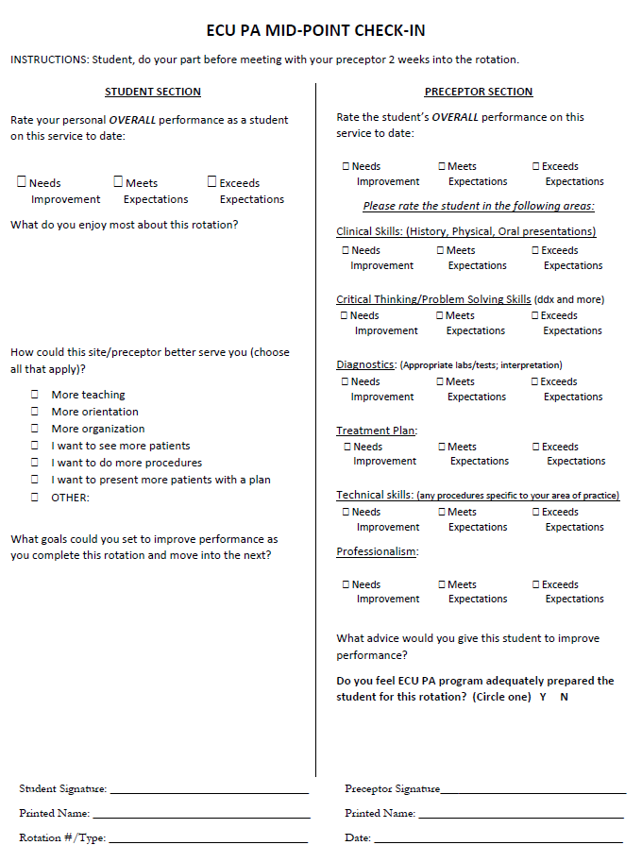

# Appendix C: (Example: Family Medicine Final Preceptor Evaluation)

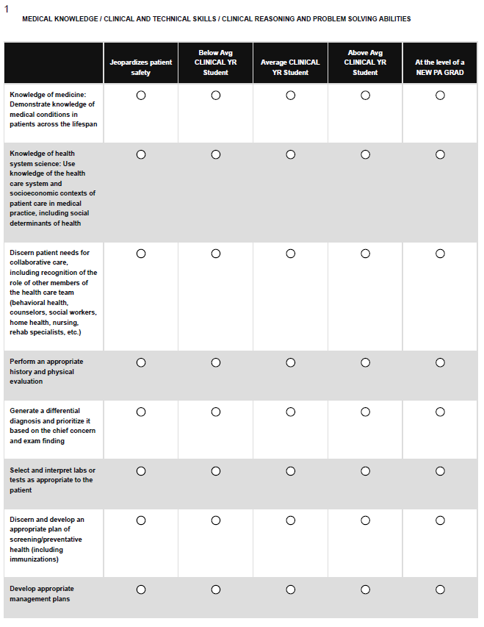

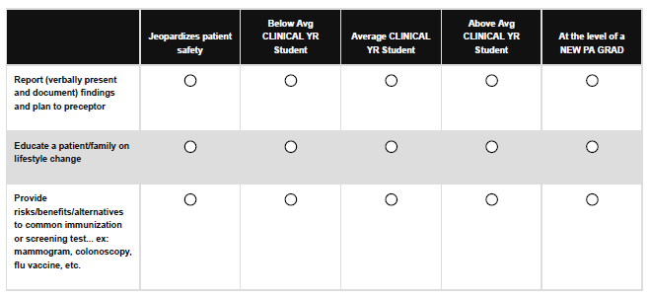

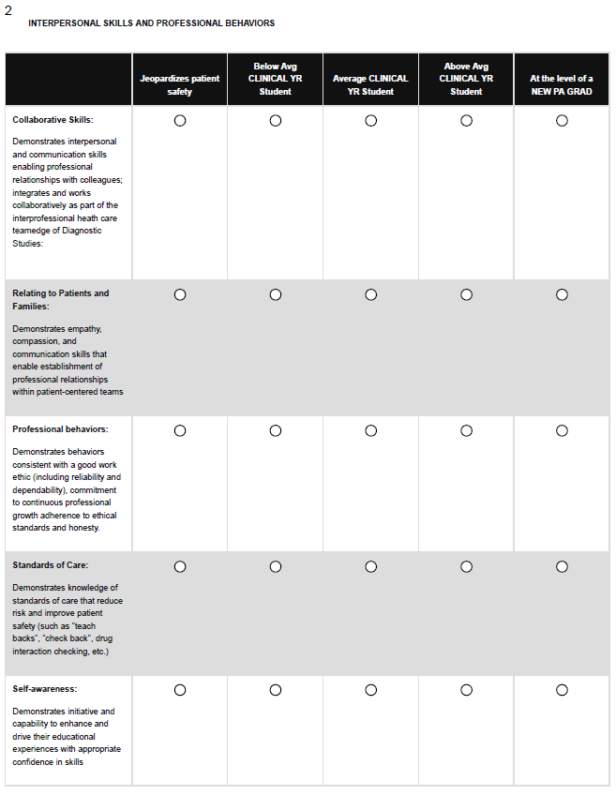

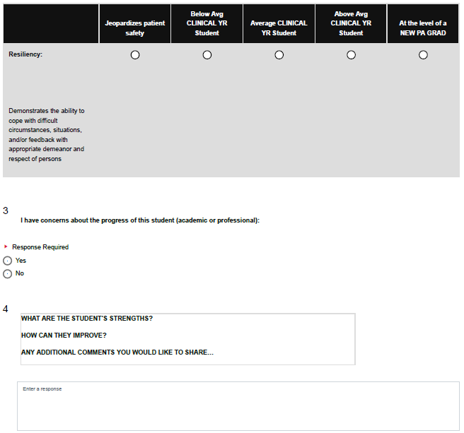

# Appendix D: (Example: SCPE Evaluation – the student’s evaluation of preceptor and clinical site)

|  |  |  |  |  |  |
| --- | --- | --- | --- | --- | --- |
|  | **Unsatisfactory** | **Below Expectations** | **Met Expectations** | **Exceeded Expectations** | **Outstanding** |
| **The preceptor provided opportunities to perform histories and physicals** |  |  |  |  |  |
| **The preceptor provided**      **opportunities to make**  **diagnostic recommendations and participate in treatment planning** | | | | | |
| **The preceptor provided time to discuss cases, ask questions, and receive additional information** |  |  |  |  |  |
| **The preceptor gave more**      **responsibility and**  **independence as my skills and confidence increased** | | | | | |
| **The preceptor gave suggestions on my personal strengths and areas for improvement** |  |  |  |  |  |
| **The preceptor**      **recommended texts,**  **literature, or other resources (apps, podcasts, etc.) to enrich the learning experience** | | | | | |
| **The preceptor(s) seemed to enjoy teaching me** |  |  |  |  |  |
| **The preceptor(s) showed**      **up to date knowledge of**  **evidence based medical practices** | | | | | |
| **OVERALL, how would you rate the preceptor?** |  |  |  |  |  |

What did your **PRECPTOR(S)** do well?

 Response Required

Enter a response.

Where could your **PRECEPTOR(S)** improve? (If you rated the preceptor Below Expectations in any of the above, please give specific examples of why you rated them this way.)

 Response Required

Enter a response.

Please use the following Likert scale when answering the questions below related to your **ROTATION**.

 Response Required

|  |  |  |  |  |  |
| --- | --- | --- | --- | --- | --- |
|  | **Unsatisfactory** | **Below Expectations** | **Met Expectations** | **Exceeded Expectations** | **Outstanding** |
| **Please rate the on-boarding process (credentialing) for this site** |  |  |  |  |  |
| **Please rate the training site**      **orientation provided** | | | | | |
| **Please rate the receptiveness of the ancillary staff (nurses, aids, medical assistants, scribes, etc.) at the training site** |  |  |  |  |  |

Did you feel safe at this ROTATION?

 Yes  No

If you answered No, please explain.:

Please answer the following questions:

 Response Required

|  |  |  |
| --- | --- | --- |
|  | **Yes** | **No** |
| **Did the site provide access to parking?** |  |  |



Enter a response.

Use the following Likert scale to rate your **OVERALL ROTATION.**

 Response Required

|  |  |  |  |  |
| --- | --- | --- | --- | --- |
| **Unsatisfactory** | **Below Expectations** | **Met Expectations** | **Exceeded Expectations** | **Outstanding** |
|  |  |  |  |  |

What were the strengths of this ROTATION?

 Response Required

Enter a response.

1. What would you change about this Rotation overall?
2. If you marked anything below MET EXPECTATIONS or NO, please explain your rationale.

 Response Required